THE NAYLOR BLUEPRINT
Full-Spectrum Basestealing Analysis
Blueprint Conversion Score — Seasons 2023–2026
May 2026

1 Introduction
This report quantifies a single insight: the stolen base is not a speed contest. Josh Naylor stole 22 bags at a 95.7% success rate in 2025 while running at the 1st sprint percentile. What separates elite stealers is technique — specifically, how much ground they cover between the pitcher's first move and pitch release.
The Blueprint Conversion Score (BCS) ranks every qualified runner-season since the 2023 bigger-bases rule change by three components: (1) steal success above speed-expected, (2) ground covered above speed-expected, and (3) a squander penalty for fast runners who get caught anyway.
2026 is included at a lower attempt threshold (≥3 tracked Statcast attempts; ~1/3 of season complete as of May 2026). Small-sample scores are Bayes-shrunk toward the league mean.

2 The Metric: Secondary Distance
The foundational metric is native Statcast: gain_to_release_ft = r_secondary_lead − r_primary_lead. This is the distance (in feet) a runner covers between the pitcher's first detectable move and pitch release — the jump window.

Term | Definition
Primary lead (r_primary_lead) | Distance off first base at pitcher's first move
Secondary lead (r_secondary_lead) | Distance off first base at pitch release
Gain to release | Difference: feet covered in the jump window
Speed correlation (r) | −0.36 (slower runners cover more ground — near-speed-independent)
Correlation with SB% | +0.25 (raw), +0.29 (speed-adjusted)

The critical finding: sprint speed barely predicts how much ground a runner covers in this window. OLS slope = −0.72 ft per ft/s. The gain residual isolates a real, near-speed-independent timing and jump skill.

3 Blueprint Conversion Score (BCS)
BCS = success_resid_z + gain_resid_z − squander_z
All three terms are z-scores across 515 volume-qualified runner-seasons (2023–2026).

Component | Description
success_resid_z | Beta-Binomial steal-success posterior (shrunk to league ~75% rate), regressed on speed → residual. Rewards converting more often than speed predicts.
gain_resid_z | Mean ground covered minus what speed predicts. Rewards a big jump for how slow you are.
squander_z | CS × max(speed_z,0) × (1 + max(gain_z,0)). Only penalizes fast runners caught despite obvious speed advantage.
Beta prior | Empirical-Bayes moment-matched: α₀ = 8.74, β₀ = 1.92
Speed composite | (z(sprint) − z(hp_to_1b)) / 2 — high = fast on both peak velocity and 90-ft burst

4 Validation
- Speed independence: OLS slope = −0.72 ft per ft/s (r = −0.36). Ground covered is not a speed skill.
- Predictive validity: r(mean_gain, SB%) = +0.25; r(gain_residual, SB%) = +0.29.
- Out-of-sample: Naylor and Soto rank near the top on gain and BCS across all tracked seasons.

5 Results & Discussion

5.1 Overall Top 15 — The Blueprint
The overall Top 15 (2023–2026 pooled) is dominated by slow/medium-speed runners who time the pitcher well and convert at elite rates. Ryan McMahon (NYY 2026) leads at BCS +8.05 driven by 24.50 ft mean gain — the highest ever measured — on 3 attempts. Agustín Ramírez (MIA 2025) is the volume leader at +6.86 on 13 attempts. Josh Naylor holds two top-10 spots: 2025 (#6, +4.01) and 2026 (#7, +3.91). Juan Soto (NYM 2025) at #11 (+3.45).
Table 1 — Overall Top 15 BCS (2023–2026)
# | Player | Team | Yr | Sprint(pct) | 90ft | SB/CS | SB% | Gain ft | Gn_z | Su_z | Sq_z | BCS
1 | Ryan McMahon | NYY | 2026 | 25.7 (14%) | 4.59 | 3/0 | 100% | 24.50 | +6.44 | +1.09 | -0.53 | +8.05
2 | Agustín Ramírez | MIA | 2025 | 26.7 (30%) | 4.78 | 13/1 | 93% | 21.31 | +4.90 | +1.44 | -0.53 | +6.86
3 | Paul Goldschmidt | STL | 2024 | 26.3 (21%) | 4.58 | 10/0 | 100% | 16.70 | +2.27 | +1.79 | -0.53 | +4.59
4 | JJ Wetherholt | STL | 2026 | 27.3 (50%) | 4.30 | 5/0 | 100% | 16.84 | +2.78 | +1.14 | -0.53 | +4.45
5 | Jordan Walker | STL | 2025 | 28.7 (84%) | 4.40 | 10/0 | 100% | 15.28 | +2.32 | +1.54 | -0.53 | +4.39
6 | Josh Naylor | SEA | 2025 | 24.4 (1%) | 4.86 | 22/1 | 96% | 16.74 | +1.42 | +2.07 | -0.53 | +4.01
7 | Josh Naylor | SEA | 2026 | 24.6 (2%) | 4.73 | 9/1 | 90% | 17.73 | +2.19 | +1.20 | -0.53 | +3.91
8 | Ramón Laureano | CLE | 2023 | 27.9 (63%) | 4.40 | 11/1 | 92% | 16.94 | +2.66 | +0.72 | -0.53 | +3.90
9 | Chase DeLauter | CLE | 2026 | 26.6 (28%) | 4.48 | 2/1 | 67% | 18.97 | +3.70 | -0.37 | -0.53 | +3.85
10 | Trea Turner | PHI | 2023 | 30.3 (99%) | 4.14 | 24/0 | 100% | 13.59 | +1.74 | +1.49 | -0.53 | +3.75
11 | Juan Soto | NYM | 2025 | 25.8 (13%) | 4.58 | 30/0 | 100% | 14.18 | +0.54 | +2.39 | -0.53 | +3.45
12 | Michael A. Taylor | PIT | 2024 | 28.5 (80%) | 4.30 | 10/0 | 100% | 13.59 | +1.40 | +1.51 | -0.53 | +3.44
13 | Nico Hoerner | CHC | 2026 | 28.4 (81%) | 4.34 | 10/0 | 100% | 13.51 | +1.35 | +1.53 | -0.53 | +3.41
14 | Luis Arraez | SF | 2026 | 26.7 (33%) | 4.57 | 4/0 | 100% | 15.22 | +1.63 | +1.18 | -0.53 | +3.33
15 | Kyle Tucker | LAD | 2026 | 26.4 (25%) | 4.54 | 4/0 | 100% | 15.43 | +1.62 | +1.18 | -0.53 | +3.33
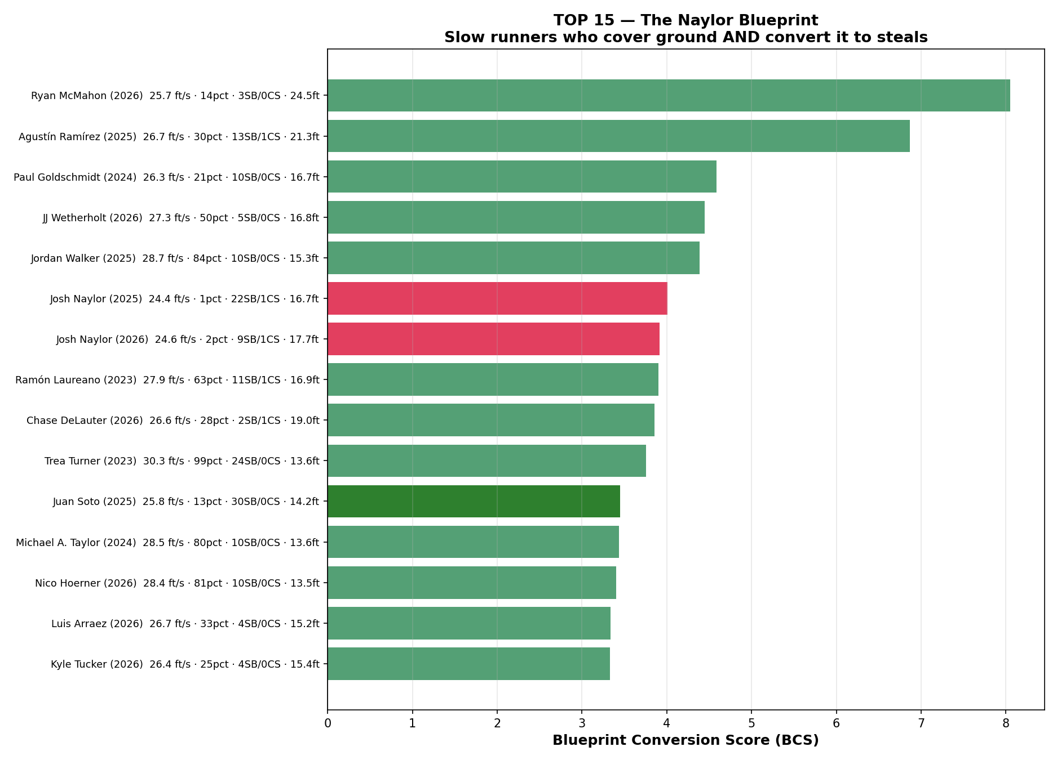
Figure 1 — Top 15 BCS runner-seasons (2023–2026). Red = Naylor. Green = Soto.

5.2 The Score in Detail
- success_resid_z rewards converting more often than sprint speed predicts — execution.
- gain_resid_z rewards covering more ground than sprint speed predicts — timing.
- squander_z penalizes fast runners who get caught. A fast runner with 8 CS has a larger penalty than a slow runner with 8 CS.

5.3 Naylor & Soto — The Archetype Profile
Table 2 — Naylor & Soto: All Seasons (2023–2026)
# | Player | Team | Yr | Sprint(pct) | 90ft | SB/CS | SB% | Gain ft | Gn_z | Su_z | Sq_z | BCS
6 | Josh Naylor | SEA | 2025 | 24.4 (1%) | 4.86 | 22/1 | 96% | 16.74 | +1.42 | +2.07 | -0.53 | +4.01
7 | Josh Naylor | SEA | 2026 | 24.6 (2%) | 4.73 | 9/1 | 90% | 17.73 | +2.19 | +1.20 | -0.53 | +3.91
209 | Juan Soto | SD | 2023 | 26.8 (34%) | 4.39 | 6/4 | 60% | 16.12 | +1.75 | -1.75 | -0.53 | +0.53
284 | Juan Soto | NYY | 2024 | 26.8 (32%) | 4.36 | 6/4 | 60% | 13.89 | +0.89 | -1.47 | -0.53 | -0.06
11 | Juan Soto | NYM | 2025 | 25.8 (13%) | 4.58 | 30/0 | 100% | 14.18 | +0.54 | +2.39 | -0.53 | +3.45
55 | Juan Soto | NYM | 2026 | 25.9 (18%) | 4.46 | 2/1 | 67% | 16.40 | +1.97 | -0.33 | -0.53 | +2.16

- Naylor 2025: 24.4 ft/s (1st pctile), 16.74 ft gain, 22/23 = 95.7% SB rate, BCS +4.01.
- Naylor 2026 (partial): 17.73 ft gain (higher than 2025), BCS +3.91 — consistent pattern.
- Soto 2025: 30/30 = 100% SB rate, BCS +3.45 — driven by elite success_resid_z (+2.39).
- Soto 2024: negative BCS (−0.06) — 6/10 season; weak success residual dragged him below neutral.
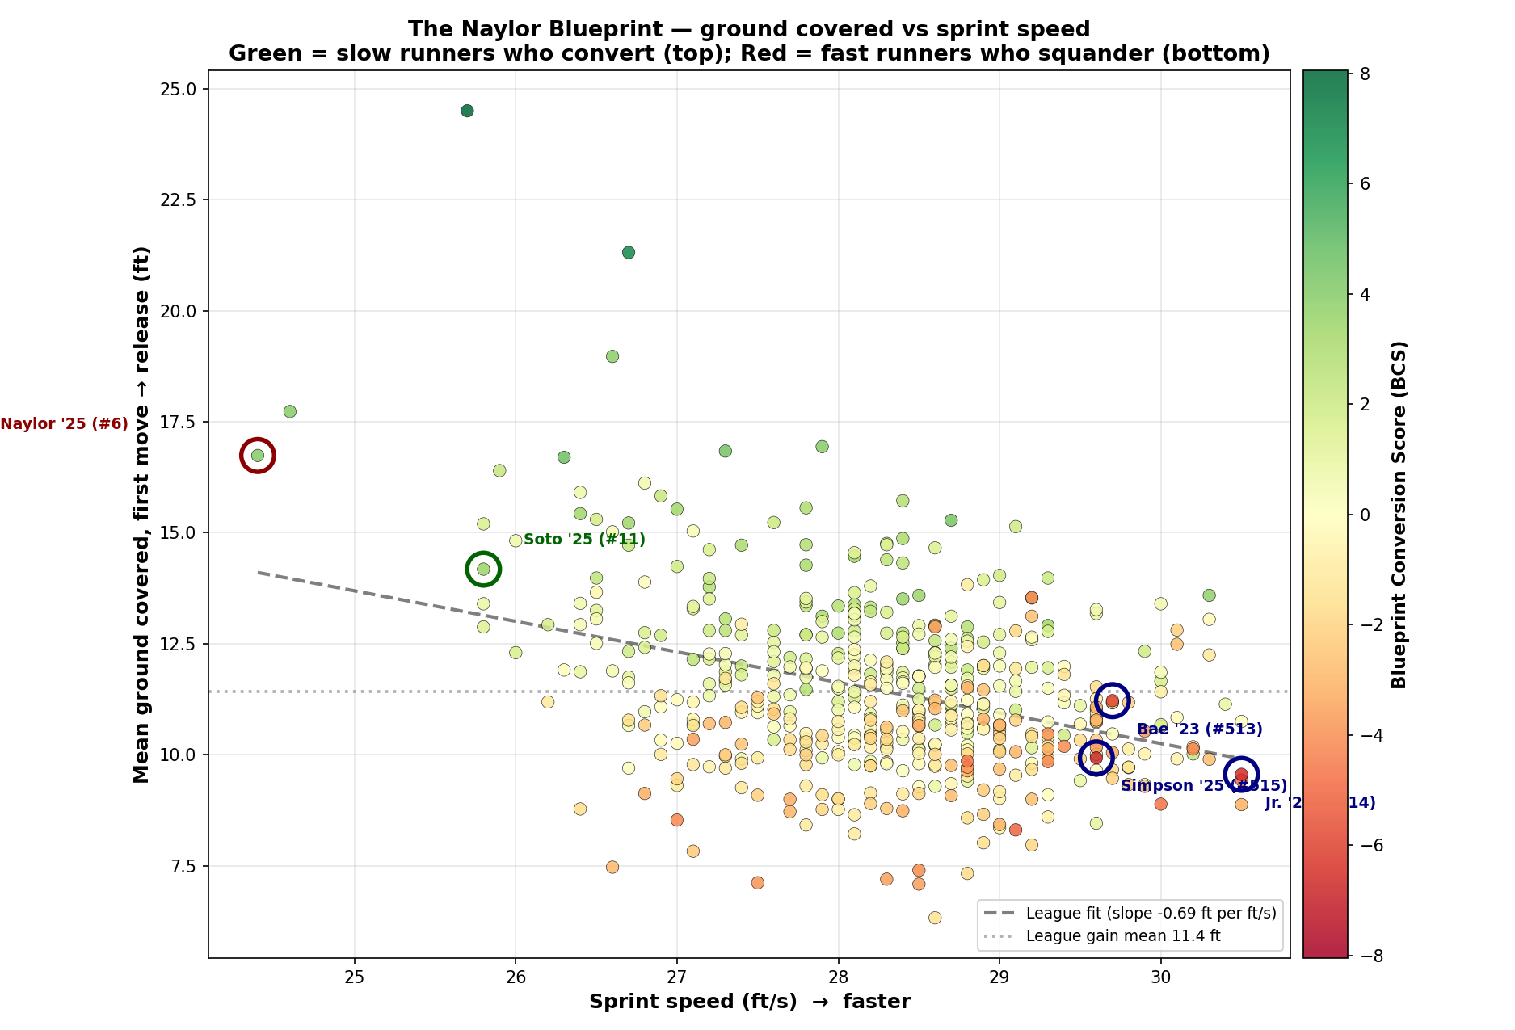
Figure 2 — BCS scatter: sprint speed vs. mean gain, colored by score. Green = high BCS. Red = low BCS. Naylor/Soto annotated.

5.4 Top 25 Per Season — Ground Covered (2023–2025)
The following tables rank the top 25 per year by speed-adjusted ground covered (gain_resid_z). This isolates the pure timing/jump sub-ranking independent of steal conversion.

Table 3 — 2023 Top 25 by Ground Covered
# | Player | Team | Sprint (pctile) | SB/CS | SB% | Gain ft | BCS
1 | Ramón Laureano | CLE | 27.9 (63%) | 11/1 | 92% | 16.94 | +3.90
2 | Trea Turner | PHI | 30.3 (99%) | 24/0 | 100% | 13.59 | +3.75
3 | Bryan Reynolds | PIT | 27.8 (62%) | 10/0 | 100% | 14.27 | +2.97
4 | Sam Haggerty | SEA | 29.2 (92%) | 10/0 | 100% | 13.53 | +2.96
5 | Lars Nootbaar | STL | 27.8 (60%) | 10/1 | 91% | 15.56 | +2.95
6 | Jonathan India | CIN | 27.8 (60%) | 12/1 | 92% | 14.73 | +2.75
7 | Spencer Steer | CIN | 28.4 (77%) | 10/2 | 83% | 15.72 | +2.71
8 | Anthony Volpe | NYY | 28.4 (75%) | 22/3 | 88% | 14.32 | +2.44
9 | Chris Taylor | LAD | 28.3 (75%) | 16/2 | 89% | 14.39 | +2.44
10 | Taylor Walls | TB | 28.2 (71%) | 20/1 | 95% | 13.32 | +2.43
11 | Mark Canha | MIL | 27.8 (60%) | 9/0 | 100% | 13.36 | +2.40
12 | Michael Harris II | ATL | 28.8 (85%) | 13/0 | 100% | 11.91 | +2.04
13 | Christian Yelich | MIL | 28.1 (69%) | 21/2 | 91% | 13.13 | +1.97
14 | Francisco Lindor | NYM | 28.1 (68%) | 24/2 | 92% | 12.79 | +1.91
15 | Jose Altuve | HOU | 26.9 (36%) | 13/0 | 100% | 12.69 | +1.88
16 | Steven Kwan | CLE | 28.1 (68%) | 14/1 | 93% | 13.28 | +1.78
17 | Jacob Young | WSH | 30.0 (98%) | 11/0 | 100% | 10.64 | +1.59
18 | Geraldo Perdomo | AZ | 27.2 (44%) | 13/3 | 81% | 14.62 | +1.52
19 | Fernando Tatis Jr. | SD | 29.3 (94%) | 24/2 | 92% | 12.78 | +1.52
20 | Mookie Betts | LAD | 27.2 (43%) | 13/2 | 87% | 13.51 | +1.40
21 | Tommy Pham | AZ | 27.8 (61%) | 15/3 | 83% | 13.44 | +1.30
22 | Michael A. Taylor | MIN | 28.7 (83%) | 13/1 | 93% | 12.09 | +1.29
23 | Daulton Varsho | TOR | 28.1 (69%) | 11/2 | 85% | 13.18 | +1.24
24 | Jack Suwinski | PIT | 28.6 (82%) | 12/1 | 92% | 12.03 | +1.21
25 | Miles Mastrobuoni | CHC | 28.6 (80%) | 10/1 | 91% | 12.21 | +1.15

Table 4 — 2024 Top 25 by Ground Covered
# | Player | Team | Sprint (pctile) | SB/CS | SB% | Gain ft | BCS
1 | Paul Goldschmidt | STL | 26.3 (21%) | 10/0 | 100% | 16.70 | +4.59
2 | Michael A. Taylor | PIT | 28.5 (80%) | 10/0 | 100% | 13.59 | +3.44
3 | Maikel Garcia | KC | 27.9 (64%) | 34/2 | 94% | 13.12 | +3.06
4 | Brandon Nimmo | NYM | 28.0 (66%) | 13/0 | 100% | 12.74 | +2.93
5 | Jake Bauers | MIL | 27.2 (43%) | 12/1 | 92% | 13.78 | +2.67
6 | Victor Robles | SEA | 27.8 (61%) | 31/0 | 100% | 11.47 | +2.63
7 | Kevin Pillar | LAA | 28.4 (78%) | 11/1 | 92% | 12.74 | +2.39
8 | Josh Lowe | TB | 28.4 (77%) | 17/1 | 94% | 12.39 | +2.31
9 | Max Schuemann | ATH | 27.8 (60%) | 13/1 | 93% | 12.71 | +2.31
10 | Zach Neto | LAA | 28.2 (74%) | 24/4 | 86% | 13.23 | +2.21
11 | Zach McKinstry | DET | 28.4 (77%) | 14/0 | 100% | 11.05 | +2.16
12 | George Springer | TOR | 28.1 (70%) | 15/1 | 94% | 11.94 | +2.15
13 | Luis García Jr. | WSH | 27.2 (45%) | 17/3 | 85% | 13.97 | +2.12
14 | Sal Frelick | MIL | 29.3 (93%) | 12/1 | 92% | 13.98 | +2.04
15 | Francisco Lindor | NYM | 27.6 (55%) | 22/3 | 88% | 12.80 | +2.02
16 | Spencer Steer | CIN | 28.2 (74%) | 13/1 | 93% | 11.82 | +1.98
17 | Mookie Betts | LAD | 26.7 (30%) | 15/1 | 94% | 12.33 | +1.92
18 | Bryson Stott | PHI | 29.1 (92%) | 27/1 | 96% | 11.01 | +1.90
19 | Whit Merrifield | ATL | 29.0 (91%) | 11/2 | 85% | 14.04 | +1.85
20 | Tyrone Taylor | NYM | 28.9 (88%) | 10/2 | 83% | 12.54 | +1.76
21 | Zack Gelof | ATH | 28.7 (84%) | 24/2 | 92% | 11.09 | +1.73
22 | Lawrence Butler | ATH | 27.6 (55%) | 18/0 | 100% | 10.34 | +1.69
23 | Jose Altuve | HOU | 27.1 (40%) | 21/4 | 84% | 13.29 | +1.66
24 | Starling Marte | NYM | 27.1 (41%) | 15/0 | 100% | 10.69 | +1.59
25 | Matt Chapman | SF | 28.7 (85%) | 9/1 | 90% | 11.49 | +1.59

Table 5 — 2025 Top 25 by Ground Covered
# | Player | Team | Sprint (pctile) | SB/CS | SB% | Gain ft | BCS
1 | Agustín Ramírez | MIA | 26.7 (30%) | 13/1 | 93% | 21.31 | +6.86
2 | Jordan Walker | STL | 28.7 (84%) | 10/0 | 100% | 15.28 | +4.39
3 | Josh Naylor | SEA | 24.4 (1%) | 22/1 | 96% | 16.74 | +4.01
4 | Juan Soto | NYM | 25.8 (13%) | 30/0 | 100% | 14.18 | +3.45
5 | Jesús Sánchez | HOU | 27.0 (38%) | 10/1 | 91% | 15.53 | +3.32
6 | Tyrone Taylor | NYM | 29.3 (94%) | 11/0 | 100% | 12.91 | +3.31
7 | Francisco Lindor | NYM | 27.4 (47%) | 25/3 | 89% | 14.72 | +3.05
8 | Nico Hoerner | CHC | 28.6 (82%) | 25/1 | 96% | 12.92 | +3.02
9 | Hyeseong Kim | LAD | 28.7 (83%) | 12/0 | 100% | 12.40 | +2.72
10 | Brandon Nimmo | NYM | 27.3 (45%) | 11/0 | 100% | 12.80 | +2.55
11 | Anthony Volpe | NYY | 28.3 (72%) | 16/4 | 80% | 14.76 | +2.38
12 | Cedric Mullins | NYM | 28.4 (77%) | 19/1 | 95% | 12.52 | +2.36
13 | Jared Triolo | PIT | 28.8 (86%) | 11/1 | 92% | 12.62 | +2.30
14 | Byron Buxton | MIN | 30.2 (99%) | 21/0 | 100% | 10.02 | +2.22
15 | Colton Cowser | BAL | 27.4 (47%) | 12/0 | 100% | 12.00 | +2.18
16 | Dansby Swanson | CHC | 28.5 (81%) | 17/1 | 94% | 11.49 | +1.86
17 | Randy Arozarena | SEA | 27.7 (55%) | 28/3 | 90% | 12.19 | +1.85
18 | Geraldo Perdomo | AZ | 27.2 (44%) | 23/3 | 88% | 12.80 | +1.83
19 | Trevor Story | BOS | 28.6 (82%) | 24/1 | 96% | 10.67 | +1.83
20 | Myles Straw | TOR | 29.4 (95%) | 11/0 | 100% | 10.44 | +1.83
21 | Jon Berti | CHC | 28.3 (74%) | 11/2 | 85% | 12.74 | +1.64
22 | Jorge Mateo | BAL | 29.3 (94%) | 14/1 | 93% | 11.96 | +1.62
23 | George Springer | TOR | 28.0 (65%) | 15/1 | 94% | 11.20 | +1.61
24 | Royce Lewis | MIN | 26.8 (32%) | 9/1 | 90% | 12.75 | +1.57
25 | Sam Haggerty | TEX | 28.9 (86%) | 11/2 | 85% | 13.94 | +1.52
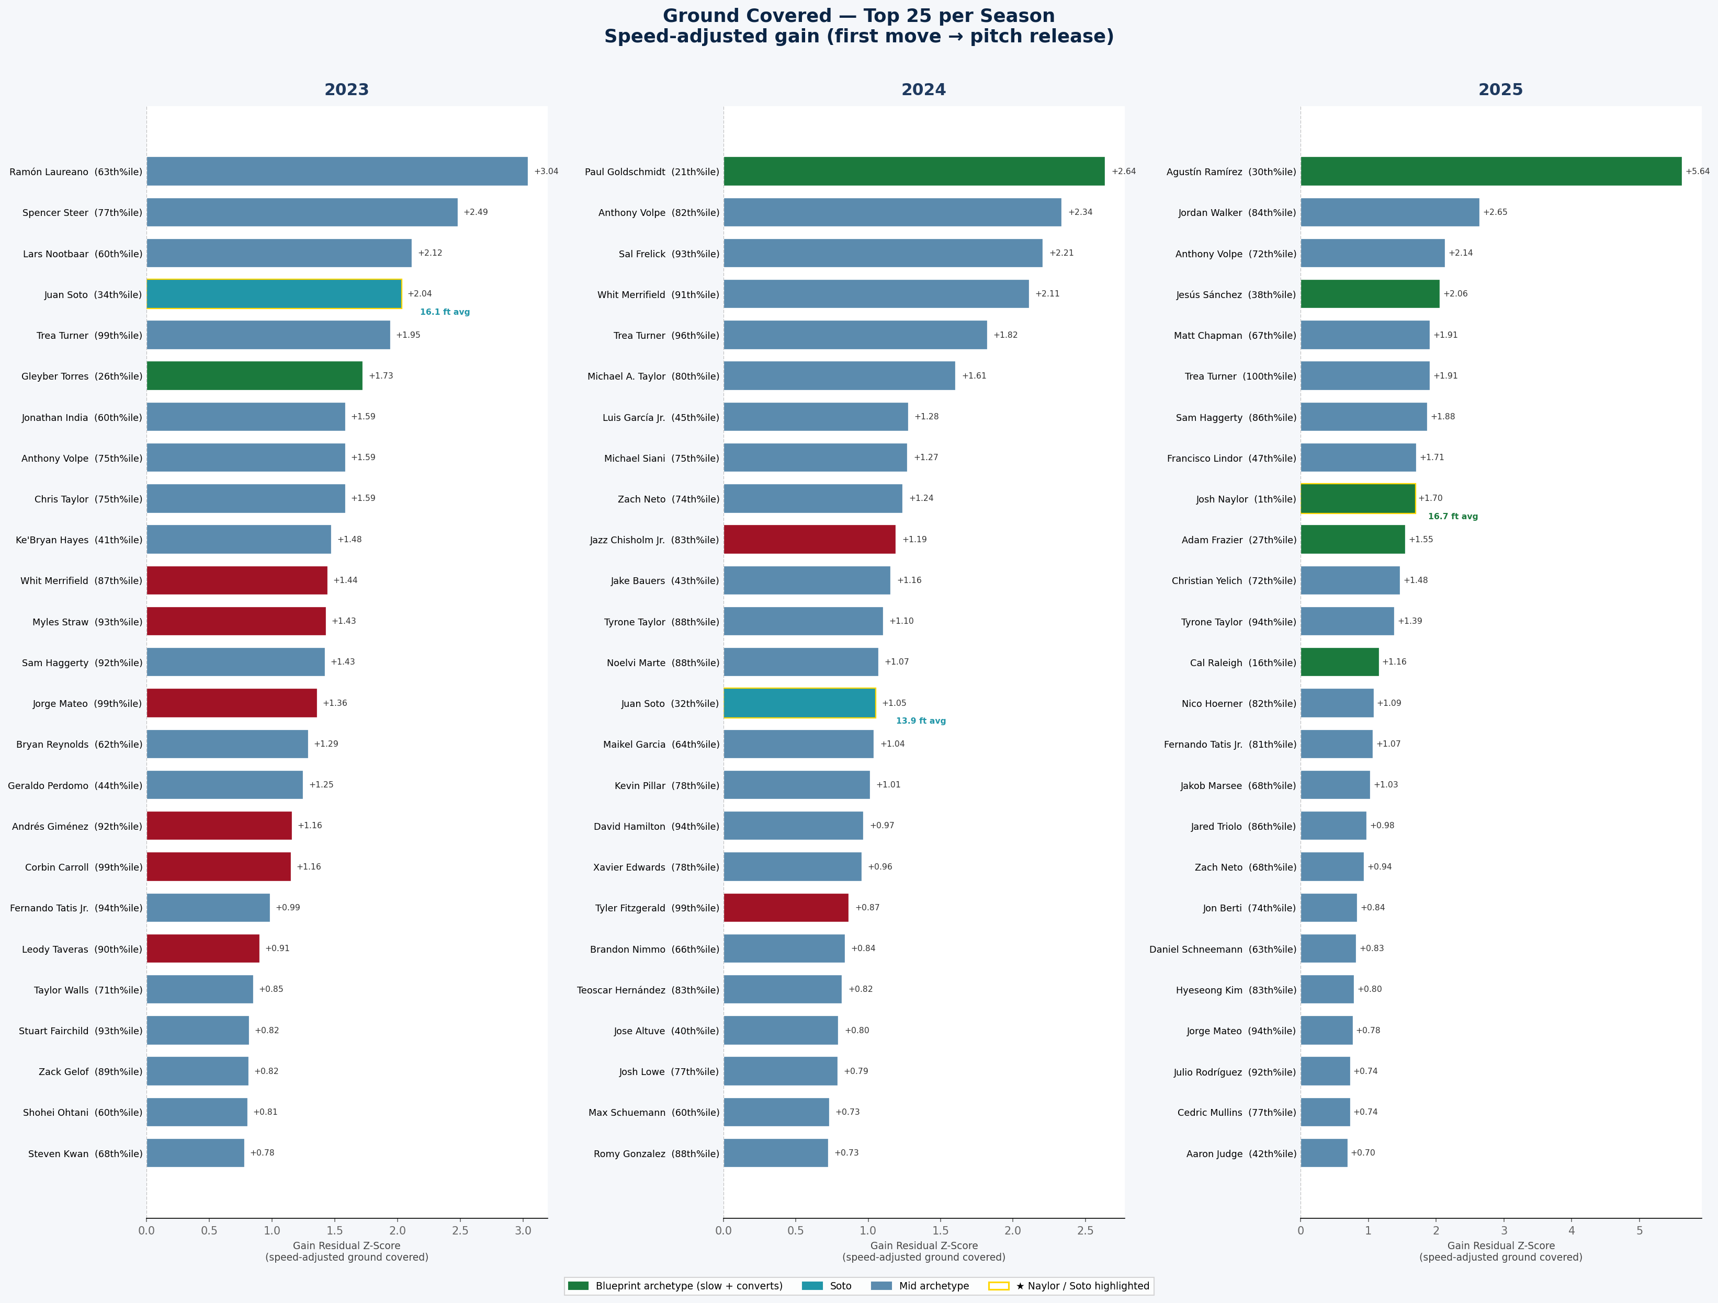
Figure 3 — Top 25 per season (2023–2025) by speed-adjusted ground covered, with team logos.

5.5 Bottom 15 — The Anti-Naylor
The bottom of the board is occupied by high-speed runners accumulating caught-stealings. Bobby Witt Jr. (KC) ranks in the bottom 5 for every season (2023: #514, 2024: #511, 2025: #508). Chandler Simpson (TB 2025) anchors at #515 (BCS −6.71): 38 SB / 8 CS from the 97th sprint percentile. The model is penalizing good sprinters who waste their edge.
Table 6 — Overall Bottom 15 BCS (2023–2026)
# | Player | Team | Yr | Sprint(pct) | 90ft | SB/CS | SB% | Gain ft | Gn_z | Su_z | Sq_z | BCS
515 | Chandler Simpson | TB | 2025 | 29.6 (96%) | 3.97 | 38/8 | 83% | 9.93 | -0.32 | -0.00 | +6.39 | -6.71
514 | Bobby Witt Jr. | KC | 2023 | 30.5 (100%) | 4.12 | 40/8 | 83% | 9.56 | -0.44 | -0.19 | +5.94 | -6.57
513 | Ji Hwan Bae | PIT | 2023 | 29.7 (97%) | 4.05 | 19/7 | 73% | 11.22 | +0.16 | -1.27 | +4.75 | -5.86
512 | Daylen Lile | WSH | 2025 | 29.1 (90%) | 4.23 | 8/6 | 57% | 8.31 | -1.43 | -2.14 | +1.47 | -5.04
511 | Bobby Witt Jr. | KC | 2024 | 30.5 (100%) | 4.10 | 25/6 | 81% | 9.43 | -0.13 | -0.22 | +4.52 | -4.87
510 | Ceddanne Rafaela | BOS | 2024 | 28.8 (88%) | 4.17 | 15/8 | 65% | 9.86 | -0.57 | -1.63 | +2.41 | -4.62
509 | Elly De La Cruz | CIN | 2024 | 30.0 (98%) | 4.21 | 55/9 | 86% | 8.89 | -0.63 | +0.49 | +4.47 | -4.60
508 | Bobby Witt Jr. | KC | 2025 | 30.2 (99%) | 4.15 | 32/7 | 82% | 10.13 | +0.03 | -0.02 | +4.34 | -4.33
507 | Myles Straw | CLE | 2023 | 29.2 (93%) | 4.14 | 17/5 | 77% | 13.54 | +1.27 | -0.74 | +4.72 | -4.20
506 | Luis Rengifo | LAA | 2025 | 27.0 (39%) | 4.36 | 7/7 | 50% | 8.53 | -2.15 | -2.57 | -0.53 | -4.20
505 | Jacob Young | WSH | 2025 | 29.3 (94%) | 4.25 | 12/7 | 63% | 9.85 | -0.49 | -1.76 | +1.87 | -4.11
504 | Jeremy Peña | HOU | 2023 | 29.4 (95%) | 4.28 | 13/7 | 65% | 10.19 | -0.53 | -1.88 | +1.67 | -4.08
503 | Alejandro Osuna | TEX | 2026 | 28.5 (81%) | 4.19 | 1/2 | 33% | 7.40 | -2.04 | -1.98 | +0.02 | -4.04
502 | David Hamilton | BOS | 2025 | 29.3 (93%) | 4.02 | 15/5 | 75% | 10.47 | -0.14 | -0.74 | +3.07 | -3.95
501 | Taylor Ward | BAL | 2026 | 27.5 (56%) | 4.47 | 1/2 | 33% | 7.12 | -2.60 | -1.78 | -0.53 | -3.85
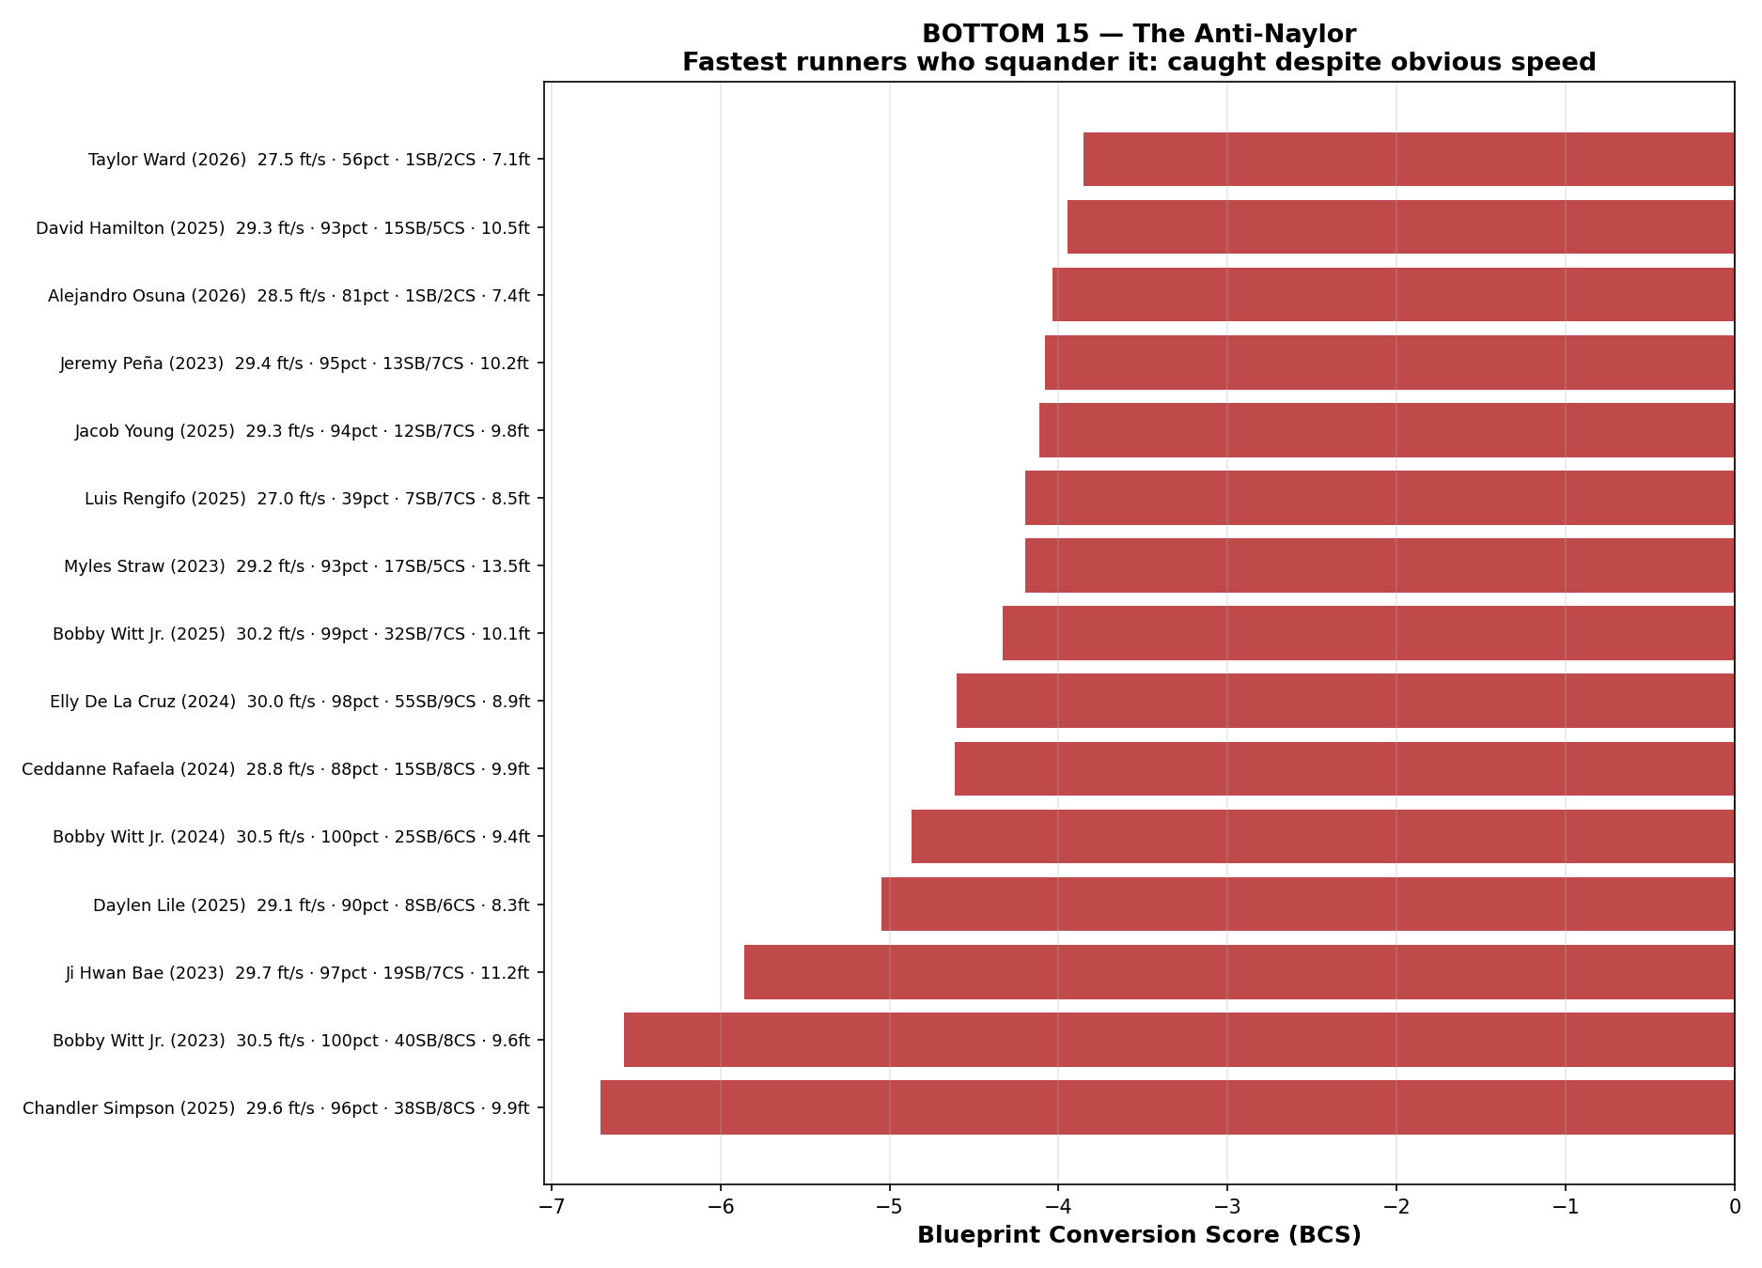
Figure 4 — Bottom 15 BCS runner-seasons. The anti-Naylor: elite speed, serial caught-stealings.

5.6 Absolute Ground Covered — Top 25 by Raw Gain
Who physically covers the most ground? Ryan McMahon (NYY 2026) leads at 24.50 ft. Agustín Ramírez (MIA 2025) is the full-season leader at 21.31 ft. Josh Naylor appears twice: 2026 at #4 (17.73 ft) and 2025 at #7 (16.74 ft). Juan Soto appears four times.
Table 7 — Top 25 BCS Runner-Seasons by Absolute Mean Gain
# | Player | Team | Season | Gain ft | Gain_z | BCS
1 | Ryan McMahon | NYY | 2026 | 24.50 | +6.44 | +8.05
2 | Agustín Ramírez | MIA | 2025 | 21.31 | +4.90 | +6.86
3 | Chase DeLauter | CLE | 2026 | 18.97 | +3.70 | +3.85
4 | Josh Naylor | SEA | 2026 | 17.73 | +2.19 | +3.91
5 | Ramón Laureano | CLE | 2023 | 16.94 | +2.66 | +3.90
6 | JJ Wetherholt | STL | 2026 | 16.84 | +2.78 | +4.45
7 | Josh Naylor | SEA | 2025 | 16.74 | +1.42 | +4.01
8 | Paul Goldschmidt | STL | 2024 | 16.70 | +2.27 | +4.59
9 | Juan Soto | NYM | 2026 | 16.40 | +1.97 | +2.16
10 | Juan Soto | SD | 2023 | 16.12 | +1.75 | +0.53
11 | Gleyber Torres | NYY | 2023 | 15.91 | +1.47 | +0.75
12 | Brett Baty | NYM | 2026 | 15.83 | +2.05 | +2.15
13 | Spencer Steer | CIN | 2023 | 15.72 | +2.17 | +2.71
14 | Lars Nootbaar | STL | 2023 | 15.56 | +1.84 | +2.95
15 | Jesús Sánchez | HOU | 2025 | 15.53 | +1.78 | +3.32
16 | Kyle Tucker | LAD | 2026 | 15.43 | +1.62 | +3.33
17 | Gabriel Moreno | AZ | 2026 | 15.30 | +1.59 | +1.70
18 | Jordan Walker | STL | 2025 | 15.28 | +2.32 | +4.39
19 | Anthony Volpe | NYY | 2026 | 15.23 | +1.99 | +2.01
20 | Luis Arraez | SF | 2026 | 15.22 | +1.63 | +3.33
21 | Cal Raleigh | SEA | 2026 | 15.20 | +1.25 | +1.53
22 | Jordan Walker | STL | 2026 | 15.14 | +2.55 | +1.85
23 | Ke'Bryan Hayes | PIT | 2023 | 15.04 | +1.26 | +0.26
24 | Adam Frazier | KC | 2025 | 15.02 | +1.33 | +0.42
25 | Jazz Chisholm Jr. | NYY | 2026 | 14.87 | +2.11 | +2.97
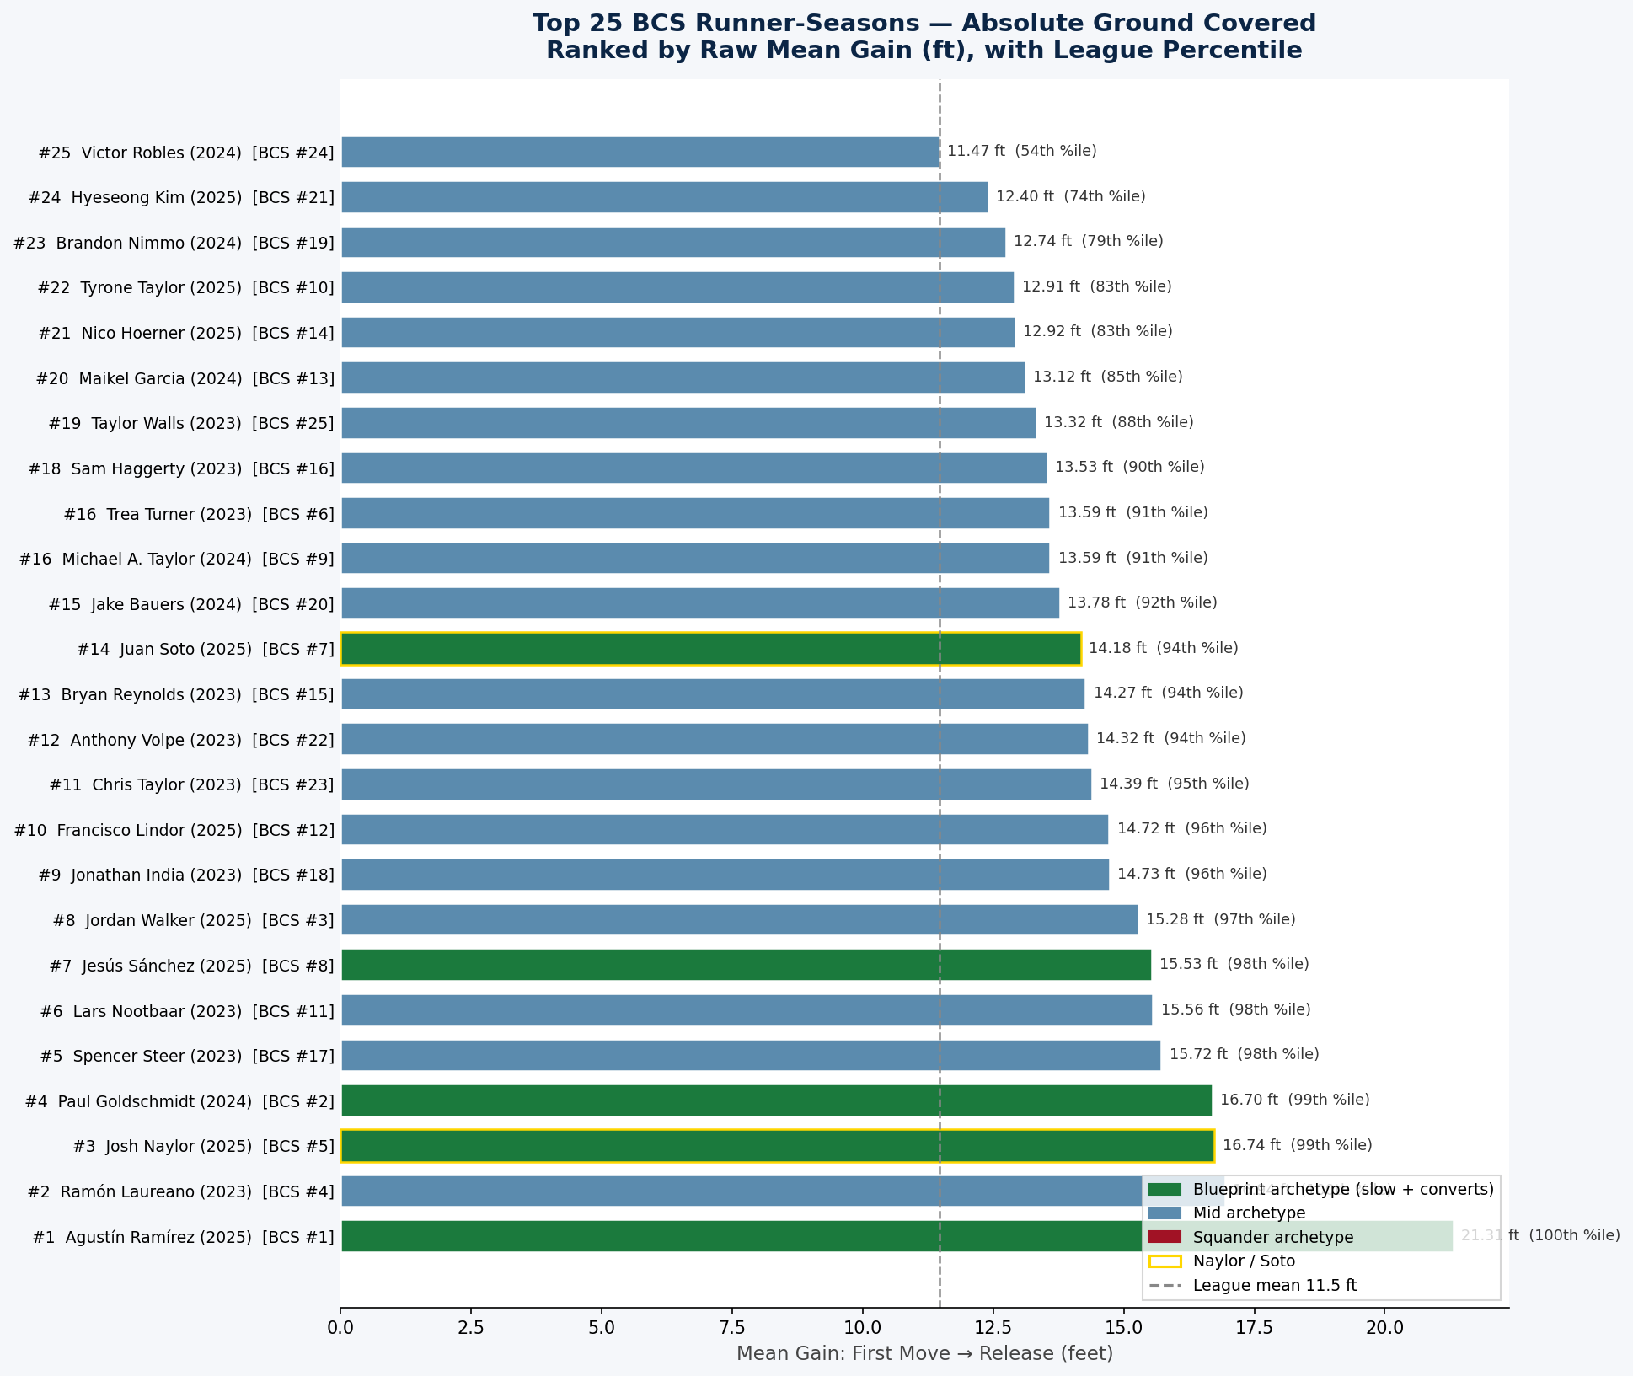
Figure 5 — Top 25 BCS runner-seasons by raw mean gain (ft). Naylor/Soto highlighted.

5.7 Per-Season BCS Top 25
Top 25 BCS runner-seasons per year since the bigger-bases rule change. Green cells = BCS ≥ 2.5. Yellow = Naylor / Soto.

2023 — Top 25 Blueprint
Table 8 — 2023 BCS Top 25
# | Player | Team | Sprint (pctile) | SB/CS | SB% | Gain ft | BCS
1 | Ramón Laureano | CLE | 27.9 (63%) | 11/1 | 92% | 16.94 | +3.90
2 | Trea Turner | PHI | 30.3 (99%) | 24/0 | 100% | 13.59 | +3.75
3 | Bryan Reynolds | PIT | 27.8 (62%) | 10/0 | 100% | 14.27 | +2.97
4 | Sam Haggerty | SEA | 29.2 (92%) | 10/0 | 100% | 13.53 | +2.96
5 | Lars Nootbaar | STL | 27.8 (60%) | 10/1 | 91% | 15.56 | +2.95
6 | Jonathan India | CIN | 27.8 (60%) | 12/1 | 92% | 14.73 | +2.75
7 | Spencer Steer | CIN | 28.4 (77%) | 10/2 | 83% | 15.72 | +2.71
8 | Anthony Volpe | NYY | 28.4 (75%) | 22/3 | 88% | 14.32 | +2.44
9 | Chris Taylor | LAD | 28.3 (75%) | 16/2 | 89% | 14.39 | +2.44
10 | Taylor Walls | TB | 28.2 (71%) | 20/1 | 95% | 13.32 | +2.43
11 | Mark Canha | MIL | 27.8 (60%) | 9/0 | 100% | 13.36 | +2.40
12 | Michael Harris II | ATL | 28.8 (85%) | 13/0 | 100% | 11.91 | +2.04
13 | Christian Yelich | MIL | 28.1 (69%) | 21/2 | 91% | 13.13 | +1.97
14 | Francisco Lindor | NYM | 28.1 (68%) | 24/2 | 92% | 12.79 | +1.91
15 | Jose Altuve | HOU | 26.9 (36%) | 13/0 | 100% | 12.69 | +1.88
16 | Steven Kwan | CLE | 28.1 (68%) | 14/1 | 93% | 13.28 | +1.78
17 | Jacob Young | WSH | 30.0 (98%) | 11/0 | 100% | 10.64 | +1.59
18 | Geraldo Perdomo | AZ | 27.2 (44%) | 13/3 | 81% | 14.62 | +1.52
19 | Fernando Tatis Jr. | SD | 29.3 (94%) | 24/2 | 92% | 12.78 | +1.52
20 | Mookie Betts | LAD | 27.2 (43%) | 13/2 | 87% | 13.51 | +1.40
21 | Tommy Pham | AZ | 27.8 (61%) | 15/3 | 83% | 13.44 | +1.30
22 | Michael A. Taylor | MIN | 28.7 (83%) | 13/1 | 93% | 12.09 | +1.29
23 | Daulton Varsho | TOR | 28.1 (69%) | 11/2 | 85% | 13.18 | +1.24
24 | Jack Suwinski | PIT | 28.6 (82%) | 12/1 | 92% | 12.03 | +1.21
25 | Miles Mastrobuoni | CHC | 28.6 (80%) | 10/1 | 91% | 12.21 | +1.15

2024 — Top 25 Blueprint
Table 9 — 2024 BCS Top 25
# | Player | Team | Sprint (pctile) | SB/CS | SB% | Gain ft | BCS
1 | Paul Goldschmidt | STL | 26.3 (21%) | 10/0 | 100% | 16.70 | +4.59
2 | Michael A. Taylor | PIT | 28.5 (80%) | 10/0 | 100% | 13.59 | +3.44
3 | Maikel Garcia | KC | 27.9 (64%) | 34/2 | 94% | 13.12 | +3.06
4 | Brandon Nimmo | NYM | 28.0 (66%) | 13/0 | 100% | 12.74 | +2.93
5 | Jake Bauers | MIL | 27.2 (43%) | 12/1 | 92% | 13.78 | +2.67
6 | Victor Robles | SEA | 27.8 (61%) | 31/0 | 100% | 11.47 | +2.63
7 | Kevin Pillar | LAA | 28.4 (78%) | 11/1 | 92% | 12.74 | +2.39
8 | Josh Lowe | TB | 28.4 (77%) | 17/1 | 94% | 12.39 | +2.31
9 | Max Schuemann | ATH | 27.8 (60%) | 13/1 | 93% | 12.71 | +2.31
10 | Zach Neto | LAA | 28.2 (74%) | 24/4 | 86% | 13.23 | +2.21
11 | Zach McKinstry | DET | 28.4 (77%) | 14/0 | 100% | 11.05 | +2.16
12 | George Springer | TOR | 28.1 (70%) | 15/1 | 94% | 11.94 | +2.15
13 | Luis García Jr. | WSH | 27.2 (45%) | 17/3 | 85% | 13.97 | +2.12
14 | Sal Frelick | MIL | 29.3 (93%) | 12/1 | 92% | 13.98 | +2.04
15 | Francisco Lindor | NYM | 27.6 (55%) | 22/3 | 88% | 12.80 | +2.02
16 | Spencer Steer | CIN | 28.2 (74%) | 13/1 | 93% | 11.82 | +1.98
17 | Mookie Betts | LAD | 26.7 (30%) | 15/1 | 94% | 12.33 | +1.92
18 | Bryson Stott | PHI | 29.1 (92%) | 27/1 | 96% | 11.01 | +1.90
19 | Whit Merrifield | ATL | 29.0 (91%) | 11/2 | 85% | 14.04 | +1.85
20 | Tyrone Taylor | NYM | 28.9 (88%) | 10/2 | 83% | 12.54 | +1.76
21 | Zack Gelof | ATH | 28.7 (84%) | 24/2 | 92% | 11.09 | +1.73
22 | Lawrence Butler | ATH | 27.6 (55%) | 18/0 | 100% | 10.34 | +1.69
23 | Jose Altuve | HOU | 27.1 (40%) | 21/4 | 84% | 13.29 | +1.66
24 | Starling Marte | NYM | 27.1 (41%) | 15/0 | 100% | 10.69 | +1.59
25 | Matt Chapman | SF | 28.7 (85%) | 9/1 | 90% | 11.49 | +1.59

2025 — Top 25 Blueprint
Table 10 — 2025 BCS Top 25
# | Player | Team | Sprint (pctile) | SB/CS | SB% | Gain ft | BCS
1 | Agustín Ramírez | MIA | 26.7 (30%) | 13/1 | 93% | 21.31 | +6.86
2 | Jordan Walker | STL | 28.7 (84%) | 10/0 | 100% | 15.28 | +4.39
3 | Josh Naylor | SEA | 24.4 (1%) | 22/1 | 96% | 16.74 | +4.01
4 | Juan Soto | NYM | 25.8 (13%) | 30/0 | 100% | 14.18 | +3.45
5 | Jesús Sánchez | HOU | 27.0 (38%) | 10/1 | 91% | 15.53 | +3.32
6 | Tyrone Taylor | NYM | 29.3 (94%) | 11/0 | 100% | 12.91 | +3.31
7 | Francisco Lindor | NYM | 27.4 (47%) | 25/3 | 89% | 14.72 | +3.05
8 | Nico Hoerner | CHC | 28.6 (82%) | 25/1 | 96% | 12.92 | +3.02
9 | Hyeseong Kim | LAD | 28.7 (83%) | 12/0 | 100% | 12.40 | +2.72
10 | Brandon Nimmo | NYM | 27.3 (45%) | 11/0 | 100% | 12.80 | +2.55
11 | Anthony Volpe | NYY | 28.3 (72%) | 16/4 | 80% | 14.76 | +2.38
12 | Cedric Mullins | NYM | 28.4 (77%) | 19/1 | 95% | 12.52 | +2.36
13 | Jared Triolo | PIT | 28.8 (86%) | 11/1 | 92% | 12.62 | +2.30
14 | Byron Buxton | MIN | 30.2 (99%) | 21/0 | 100% | 10.02 | +2.22
15 | Colton Cowser | BAL | 27.4 (47%) | 12/0 | 100% | 12.00 | +2.18
16 | Dansby Swanson | CHC | 28.5 (81%) | 17/1 | 94% | 11.49 | +1.86
17 | Randy Arozarena | SEA | 27.7 (55%) | 28/3 | 90% | 12.19 | +1.85
18 | Geraldo Perdomo | AZ | 27.2 (44%) | 23/3 | 88% | 12.80 | +1.83
19 | Trevor Story | BOS | 28.6 (82%) | 24/1 | 96% | 10.67 | +1.83
20 | Myles Straw | TOR | 29.4 (95%) | 11/0 | 100% | 10.44 | +1.83
21 | Jon Berti | CHC | 28.3 (74%) | 11/2 | 85% | 12.74 | +1.64
22 | Jorge Mateo | BAL | 29.3 (94%) | 14/1 | 93% | 11.96 | +1.62
23 | George Springer | TOR | 28.0 (65%) | 15/1 | 94% | 11.20 | +1.61
24 | Royce Lewis | MIN | 26.8 (32%) | 9/1 | 90% | 12.75 | +1.57
25 | Sam Haggerty | TEX | 28.9 (86%) | 11/2 | 85% | 13.94 | +1.52

2026 — Top 25 Blueprint (Partial Season)
Table 11 — 2026 BCS Top 25 †
# | Player | Team | Sprint (pctile) | SB/CS | SB% | Gain ft | BCS
1 | Ryan McMahon | NYY | 25.7 (14%) | 3/0 | 100% | 24.50 | +8.05
2 | JJ Wetherholt | STL | 27.3 (50%) | 5/0 | 100% | 16.84 | +4.45
3 | Josh Naylor | SEA | 24.6 (2%) | 9/1 | 90% | 17.73 | +3.91
4 | Chase DeLauter | CLE | 26.6 (28%) | 2/1 | 67% | 18.97 | +3.85
5 | Nico Hoerner | CHC | 28.4 (81%) | 10/0 | 100% | 13.51 | +3.41
6 | Luis Arraez | SF | 26.7 (33%) | 4/0 | 100% | 15.22 | +3.33
7 | Kyle Tucker | LAD | 26.4 (25%) | 4/0 | 100% | 15.43 | +3.33
8 | Masyn Winn | STL | 28.1 (70%) | 4/0 | 100% | 14.47 | +3.28
9 | Jazz Chisholm Jr. | NYY | 28.4 (80%) | 10/1 | 91% | 14.87 | +2.97
10 | Miguel Vargas | CWS | 28.1 (71%) | 6/0 | 100% | 13.38 | +2.91
11 | Nasim Nuñez | WSH | 29.7 (97%) | 19/0 | 100% | 11.17 | +2.81
12 | Xander Bogaerts | SD | 27.3 (50%) | 7/0 | 100% | 13.06 | +2.62
13 | Dansby Swanson | CHC | 28.0 (68%) | 4/0 | 100% | 13.35 | +2.62
14 | Zack Gelof | ATH | 28.8 (89%) | 4/0 | 100% | 12.88 | +2.61
15 | Randy Arozarena | SEA | 27.1 (44%) | 14/0 | 100% | 12.15 | +2.45
16 | Sal Stewart | CIN | 26.5 (27%) | 9/1 | 90% | 13.98 | +2.43
17 | Nick Kurtz | ATH | 26.7 (34%) | 5/1 | 83% | 14.72 | +2.24
18 | Heriberto Hernández | MIA | 28.6 (85%) | 3/0 | 100% | 12.57 | +2.21
19 | Juan Soto | NYM | 25.9 (18%) | 2/1 | 67% | 16.40 | +2.16
20 | Brett Baty | NYM | 26.9 (39%) | 2/1 | 67% | 15.83 | +2.15
21 | Bryan Reynolds | PIT | 28.0 (69%) | 4/0 | 100% | 12.28 | +2.03
22 | Anthony Volpe | NYY | 27.6 (57%) | 2/1 | 67% | 15.23 | +2.01
23 | Jake Fraley | TB | 28.4 (81%) | 3/0 | 100% | 12.40 | +2.00
24 | Alek Thomas | AZ | 27.8 (64%) | 3/0 | 100% | 12.70 | +1.98
25 | Kevin McGonigle | DET | 28.1 (72%) | 7/0 | 100% | 11.37 | +1.89
† 2026 data through May 30, 2026 (~1/3 of season complete). Minimum: 3 tracked Statcast attempts (vs. standard 10). Small-sample scores are Bayes-shrunk toward the league mean.

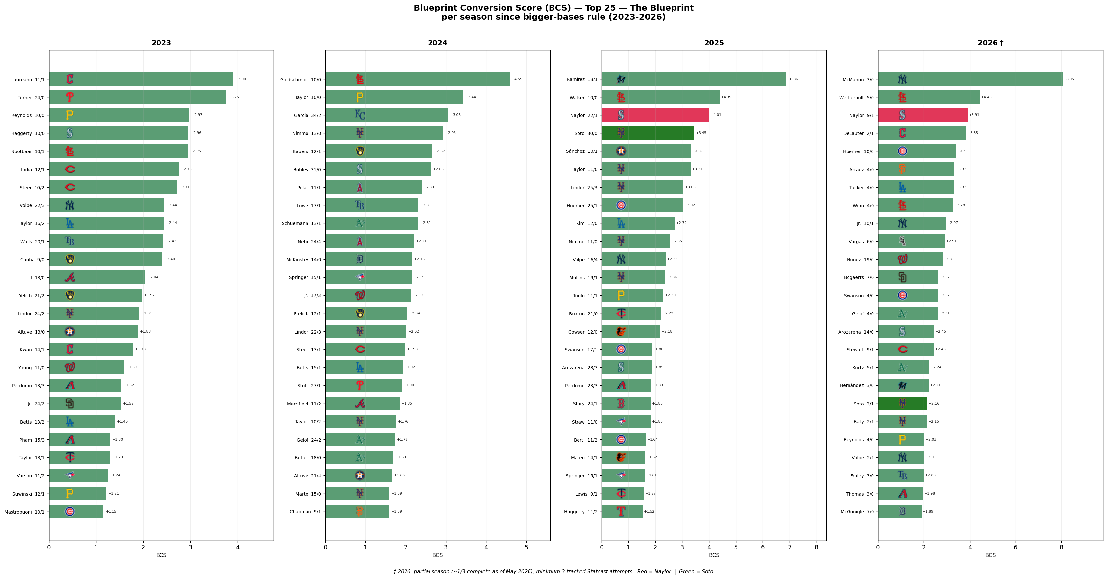
Figure 6 — Top 25 BCS per season (2023–2026) with team logos. Red = Naylor. Green = Soto. † 2026 partial season.

5.8 Per-Season BCS Bottom 25 — The Squanderers
Bottom 25 per year. Red cells = BCS ≤ −3.5. Bobby Witt Jr. and Chandler Simpson appear repeatedly.

2023 — Bottom 25 Squanderers
Table 12 — 2023 BCS Bottom 25
# | Player | Team | Sprint (pctile) | SB/CS | SB% | Gain ft | BCS
1 | Bobby Witt Jr. | KC | 30.5 (100%) | 40/8 | 83% | 9.56 | -6.57
2 | Ji Hwan Bae | PIT | 29.7 (97%) | 19/7 | 73% | 11.22 | -5.86
3 | Myles Straw | CLE | 29.2 (93%) | 17/5 | 77% | 13.54 | -4.20
4 | Jeremy Peña | HOU | 29.4 (95%) | 13/7 | 65% | 10.19 | -4.08
5 | Seiya Suzuki | CHC | 28.5 (79%) | 5/6 | 46% | 10.66 | -3.37
6 | Alex Call | WSH | 28.8 (85%) | 7/6 | 54% | 11.51 | -3.19
7 | Elly De La Cruz | CIN | 30.5 (99%) | 31/4 | 89% | 8.88 | -3.09
8 | Matt McLain | CIN | 29.0 (89%) | 10/5 | 67% | 10.67 | -3.07
9 | Ezequiel Duran | TEX | 29.1 (91%) | 7/4 | 64% | 10.07 | -2.99
10 | Akil Baddoo | DET | 29.0 (89%) | 11/3 | 79% | 9.68 | -2.69
11 | Dairon Blanco | KC | 30.3 (99%) | 23/4 | 85% | 9.90 | -2.68
12 | Andrés Giménez | CLE | 29.2 (92%) | 25/5 | 83% | 13.12 | -2.63
13 | Corbin Carroll | AZ | 30.1 (99%) | 43/4 | 92% | 12.49 | -2.59
14 | Cody Bellinger | CHC | 28.3 (74%) | 17/5 | 77% | 10.62 | -2.45
15 | Brenton Doyle | COL | 29.9 (97%) | 20/4 | 83% | 9.29 | -2.45
16 | Randy Arozarena | TB | 28.4 (75%) | 20/8 | 71% | 10.99 | -2.45
17 | Will Brennan | CLE | 28.3 (73%) | 10/4 | 71% | 8.79 | -2.31
18 | Esteury Ruiz | ATH | 29.6 (96%) | 57/10 | 85% | 10.33 | -2.23
19 | Chas McCormick | HOU | 28.2 (72%) | 18/6 | 75% | 8.90 | -2.12
20 | Jorge Mateo | BAL | 30.1 (99%) | 28/4 | 88% | 12.81 | -2.02
21 | Matt Vierling | DET | 29.1 (90%) | 6/4 | 60% | 10.78 | -1.98
22 | Jose Siri | TB | 29.7 (97%) | 9/3 | 75% | 11.18 | -1.96
23 | Jarred Kelenic | SEA | 28.0 (63%) | 13/4 | 76% | 9.01 | -1.85
24 | Leody Taveras | TEX | 29.1 (90%) | 11/4 | 73% | 12.79 | -1.84
25 | Edward Olivares | KC | 28.6 (80%) | 8/4 | 67% | 10.01 | -1.82

2024 — Bottom 25 Squanderers
Table 13 — 2024 BCS Bottom 25
# | Player | Team | Sprint (pctile) | SB/CS | SB% | Gain ft | BCS
1 | Bobby Witt Jr. | KC | 30.5 (100%) | 25/6 | 81% | 9.43 | -4.87
2 | Ceddanne Rafaela | BOS | 28.8 (88%) | 15/8 | 65% | 9.86 | -4.62
3 | Elly De La Cruz | CIN | 30.0 (98%) | 55/9 | 86% | 8.89 | -4.60
4 | Jazz Chisholm Jr. | NYY | 28.6 (83%) | 26/8 | 76% | 12.88 | -3.74
5 | Jose Siri | TB | 29.9 (98%) | 13/6 | 68% | 10.53 | -3.74
6 | Jarren Duran | BOS | 29.6 (96%) | 20/6 | 77% | 10.17 | -3.69
7 | Nicky Lopez | CWS | 27.1 (42%) | 4/6 | 40% | 10.35 | -3.53
8 | Jacob Young | WSH | 29.7 (97%) | 28/7 | 80% | 10.05 | -3.32
9 | Lane Thomas | CLE | 29.3 (94%) | 26/14 | 65% | 10.13 | -3.24
10 | Adolis García | TEX | 26.8 (31%) | 6/5 | 54% | 9.13 | -3.18
11 | Masyn Winn | STL | 28.8 (87%) | 9/5 | 64% | 9.64 | -3.09
12 | Connor Wong | BOS | 28.4 (77%) | 7/6 | 54% | 8.74 | -3.08
13 | Corbin Carroll | AZ | 29.6 (96%) | 31/6 | 84% | 10.78 | -3.03
14 | Christopher Morel | TB | 27.3 (45%) | 6/7 | 46% | 10.73 | -2.93
15 | Joey Ortiz | MIL | 28.7 (85%) | 6/4 | 60% | 9.08 | -2.83
16 | James Wood | WSH | 28.7 (85%) | 13/5 | 72% | 9.76 | -2.66
17 | Vidal Bruján | MIA | 27.5 (52%) | 5/6 | 46% | 11.29 | -2.51
18 | Brayan Rocchio | CLE | 26.8 (33%) | 8/6 | 57% | 10.67 | -2.21
19 | Jonny DeLuca | TB | 29.8 (98%) | 15/4 | 79% | 9.33 | -2.21
20 | Tyler Freeman | CLE | 28.2 (73%) | 6/5 | 54% | 10.37 | -2.00
21 | Willi Castro | MIN | 27.9 (64%) | 11/7 | 61% | 10.43 | -1.90
22 | José Caballero | TB | 28.3 (76%) | 39/13 | 75% | 10.35 | -1.89
23 | Jackson Chourio | MIL | 29.7 (97%) | 19/4 | 83% | 9.66 | -1.82
24 | Parker Meadows | DET | 29.3 (94%) | 9/3 | 75% | 9.92 | -1.77
25 | Jo Adell | LAA | 28.8 (88%) | 13/8 | 62% | 10.02 | -1.74

2025 — Bottom 25 Squanderers
Table 14 — 2025 BCS Bottom 25
# | Player | Team | Sprint (pctile) | SB/CS | SB% | Gain ft | BCS
1 | Chandler Simpson | TB | 29.6 (96%) | 38/8 | 83% | 9.93 | -6.71
2 | Daylen Lile | WSH | 29.1 (90%) | 8/6 | 57% | 8.31 | -5.04
3 | Bobby Witt Jr. | KC | 30.2 (99%) | 32/7 | 82% | 10.13 | -4.33
4 | Luis Rengifo | LAA | 27.0 (39%) | 7/7 | 50% | 8.53 | -4.20
5 | Jacob Young | WSH | 29.3 (94%) | 12/7 | 63% | 9.85 | -4.11
6 | David Hamilton | BOS | 29.3 (93%) | 15/5 | 75% | 10.47 | -3.95
7 | Harrison Bader | PHI | 28.8 (86%) | 8/7 | 53% | 9.72 | -3.67
8 | Jackson Holliday | BAL | 28.6 (82%) | 17/9 | 65% | 11.04 | -2.93
9 | Ernie Clement | TOR | 28.6 (81%) | 5/5 | 50% | 11.23 | -2.69
10 | Brice Turang | MIL | 28.9 (87%) | 21/7 | 75% | 11.46 | -2.54
11 | Sal Frelick | MIL | 28.9 (88%) | 11/3 | 79% | 8.66 | -2.17
12 | Dylan Crews | WSH | 29.0 (89%) | 13/5 | 72% | 10.37 | -2.12
13 | Corbin Carroll | AZ | 29.8 (97%) | 26/5 | 84% | 11.18 | -2.05
14 | Heliot Ramos | SF | 27.5 (50%) | 6/3 | 67% | 9.09 | -2.02
15 | Otto Lopez | MIA | 28.5 (79%) | 13/4 | 76% | 9.13 | -2.00
16 | Oneil Cruz | PIT | 29.2 (93%) | 33/5 | 87% | 7.97 | -1.95
17 | Pete Crow-Armstrong | CHC | 29.5 (96%) | 26/5 | 84% | 9.91 | -1.85
18 | Jackson Chourio | MIL | 29.2 (92%) | 17/5 | 77% | 10.41 | -1.69
19 | James Wood | WSH | 27.8 (58%) | 13/5 | 72% | 9.78 | -1.68
20 | Matt Shaw | CHC | 29.0 (89%) | 12/5 | 71% | 10.66 | -1.67
21 | Jarren Duran | BOS | 29.1 (91%) | 22/5 | 82% | 11.94 | -1.28
22 | Willi Castro | CHC | 28.2 (70%) | 10/3 | 77% | 9.14 | -1.24
23 | Tyler Soderstrom | ATH | 27.4 (46%) | 7/2 | 78% | 9.26 | -1.15
24 | Mike Yastrzemski | KC | 26.9 (36%) | 6/2 | 75% | 10.01 | -1.09
25 | Elly De La Cruz | CIN | 29.1 (92%) | 25/5 | 83% | 9.54 | -1.05

2026 — Bottom 25 Squanderers (Partial Season)
Table 15 — 2026 BCS Bottom 25 †
# | Player | Team | Sprint (pctile) | SB/CS | SB% | Gain ft | BCS
1 | Alejandro Osuna | TEX | 28.5 (81%) | 1/2 | 33% | 7.40 | -4.04
2 | Taylor Ward | BAL | 27.5 (56%) | 1/2 | 33% | 7.12 | -3.85
3 | Joey Ortiz | MIL | 28.5 (82%) | 3/3 | 50% | 7.09 | -3.55
4 | Elly De La Cruz | CIN | 28.3 (78%) | 5/4 | 56% | 7.20 | -3.52
5 | Chandler Simpson | TB | 29.6 (96%) | 12/4 | 75% | 11.07 | -3.15
6 | Cole Young | SEA | 27.7 (61%) | 2/3 | 40% | 9.00 | -3.15
7 | Ceddanne Rafaela | BOS | 28.9 (90%) | 4/4 | 50% | 10.80 | -3.13
8 | Luis Robert Jr. | NYM | 29.0 (92%) | 1/2 | 33% | 8.43 | -2.98
9 | Willy Adames | SF | 27.7 (59%) | 1/2 | 33% | 8.72 | -2.91
10 | Riley Greene | DET | 26.6 (31%) | 1/1 | 50% | 7.47 | -2.87
11 | Munetaka Murakami | CWS | 27.2 (48%) | 1/3 | 25% | 10.70 | -2.79
12 | Daylen Lile | WSH | 29.2 (94%) | 2/2 | 50% | 9.00 | -2.63
13 | Isaac Collins | KC | 27.4 (54%) | 2/3 | 40% | 10.24 | -2.49
14 | Cody Bellinger | NYY | 27.6 (58%) | 2/3 | 40% | 10.92 | -2.36
15 | Luis Rengifo | MIL | 27.1 (43%) | 2/1 | 67% | 7.83 | -2.31
16 | Miguel Andujar | SD | 27.3 (51%) | 1/2 | 33% | 10.00 | -2.30
17 | Fernando Tatis Jr. | SD | 28.9 (90%) | 10/5 | 67% | 9.21 | -2.24
18 | A.J. Ewing | NYM | 29.0 (92%) | 3/3 | 50% | 10.07 | -2.17
19 | Jake Meyers | HOU | 27.8 (65%) | 1/2 | 33% | 10.00 | -2.10
20 | Justin Crawford | PHI | 29.7 (97%) | 4/2 | 67% | 9.47 | -2.07
21 | Bryce Harper | PHI | 27.0 (41%) | 3/2 | 60% | 9.46 | -1.94
22 | Jose Altuve | HOU | 27.9 (67%) | 1/1 | 50% | 8.77 | -1.88
23 | José Caballero | NYY | 28.2 (74%) | 8/5 | 62% | 10.78 | -1.76
24 | Brice Matthews | HOU | 28.2 (75%) | 2/2 | 50% | 9.75 | -1.76
25 | Max Schuemann | NYY | 27.7 (61%) | 2/2 | 50% | 10.12 | -1.75
† 2026 partial season — same caveats as Table 11.

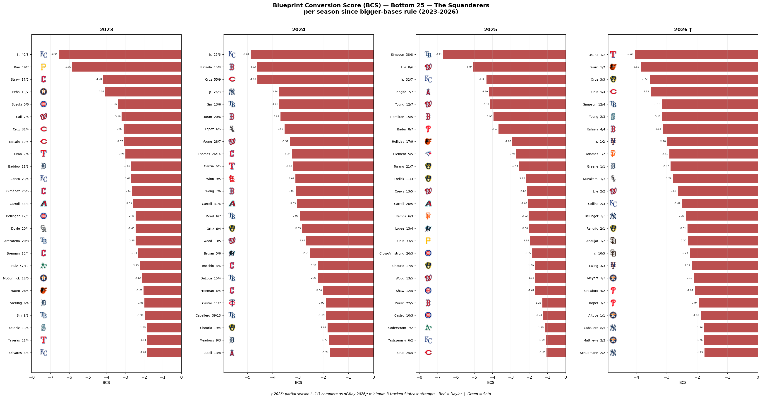
Figure 7 — Bottom 25 BCS per season (2023–2026). The squanderer pattern: fast, caught repeatedly. † 2026 partial season.

6 Conclusions
- Ground covered (first move → release) is near-speed-independent. Sprint speed explains only a small fraction of the variance (r = −0.36, slope −0.72 ft per ft/s).
- The gain metric meaningfully predicts steal success (r = +0.25–0.29 with SB%). The signal is real.
- The Naylor archetype — slow sprint, big jump, high conversion rate — appears in every season and is not a single-year outlier. Naylor 2026 is already tracking above his 2025 pace.
- The squander archetype — fast sprint, serial caught-stealings — is equally stable. Bobby Witt Jr. is in the bottom five every season in the dataset.
The practical implication: timing and jump training can shift BCS scores for runners at both ends of the speed spectrum. Sprint speed is structural. The jump window is behavioral.

